Automatic Bartender

Automatic Bartender, as the name suggests, is a mechanism which will mix many fluids together in a predetermined ratio to give the required resultant mixture. This would enhance the accuracy with which the drink is prepared and also improve the serving rate in bars and pubs. It can also be used to mix hazardous fluids automatically and as a result enhancing safety.

# Methodology

Possible methods to calculating the discharge volumetric flow rate for each fluid

Discharge volume can be controlled by directly sensing the level of fluid in bottle. However, this approach requires a continuous level sensor which is difficult to integrate with variations in ingredient container. Also, the dimensions of container need to be known. Thus, this approach is REJECTED.

Discharge volume can be controlled by computing the time required for relevant flow. This can be done by integrating the exit velocity function with respect to time. However, this approach is computationally complex and difficult to implement practically. Thus, this approach is REJECTED.

Discharge volume can be controlled by fixing fluid level using a container to get constant exit velocity. This approach can be implemented using a single point level sensor. This approach is independent of the geometry of ingredient container. Thus, this approach is SELECTED.

# Sample Calculation

Classic Shirley Temple recipe (fabulousfoods.com)

Ingredients:-

* 250 ml lemon-lime soda (2.5 x 10^-4 m3)
* 25 ml grenadine (2.5 x 10^-5 m3)
* 15 ml orange juice (1.5x 10^-5 m3)

Geometric data has been taken from CAD model.

$$Exit velocity of liquid v=\sqrt{2gh} ∀ g=9.8 m/{s^{2}, h=16.5mm}$$

$$v=.56868 m/s$$

Diameter of hole=16.5 mm

Escape Area = .0002138 m2

Escape volume flow rate = .00012158 m3/s

Thus time to open the solenoid valves for each ingredient is = 2.05s, .21s, .12s respectively

The model is setup as shown in the cad model.

# CAD Model

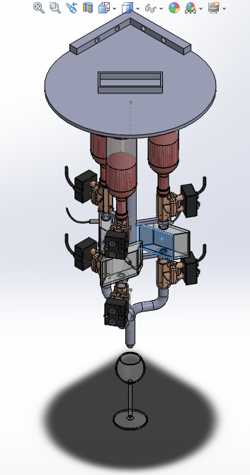

Output nozzle

Ingredient bottle

Solenoid valve

Level sensor

Solenoid valve

Glass

The ‘Automatic Bartender’ contains ingredient containers at the top which can be changed when empty. The fluids flow into a temporary container where a constant level is maintained using a single point level sensor. The user selects the mixture using pre-programmed buttons and the nozzle would pour the mixture into the glass.

# PLC Logic

I1 = Main machine ON/OFF control switch

I2, I3, I4 = Level Sensor Input (On when container full)

Q1, Q2, Q3 = Upper Solenoid Valve Output

I5 = Mixture 1 selection button (user input)

T1, T2, T3 = On-Delay Timer based on sample calculations

Q4, Q5, Q6 = Lower Solenoid Valve Output